
1 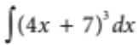= 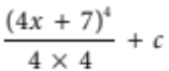
MATHEMATICS DEPARTMENT

Year 12 Methods - Test Number 4 - 2016
Integration and Logarithms
Resource Rich - SOLUTIONS
= (4x  7)4
   B [1 mark]
2 Area between x = 10 and x = 6 is 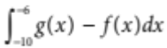
Area between x = 6 and x = 0 is 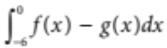
Total area = 
 D [1 mark]
3 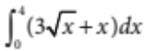= 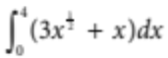
= 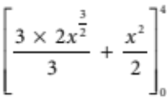
= 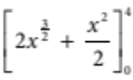
= 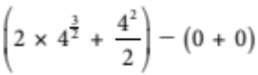
= 2 × 23  8
= 24
 A [1 mark]
4 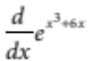= 3(x2  2) 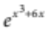
So 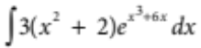 = 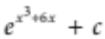
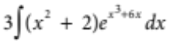=
So 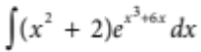 = 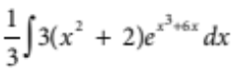
= 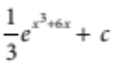
 C [1 mark]
5 Total change = 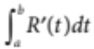
= 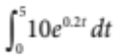
= 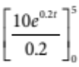
= 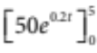
= 50e1  50e0
= 85.914…
 B [1 mark]
6 B [1 mark]
7 B [1 mark]
8 A [1 mark]
9 A [1 mark]
10 D [1 mark]
11 a 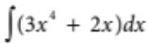 = 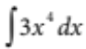 + 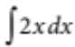
= 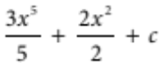
= 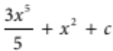 [1 mark]
b 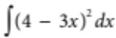 = 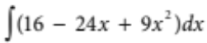
= 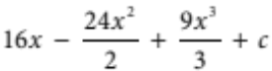
= 16x  12x2  3x3  c =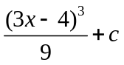 [1 mark]
c 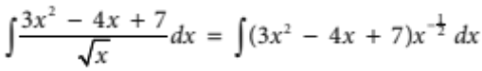
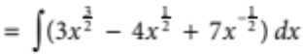
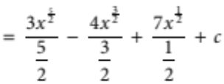
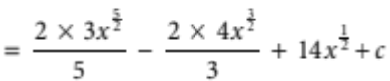
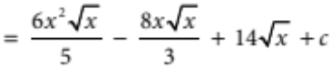 [2 marks]

12 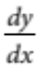= 14x  4
y = 7x2  4x  c [1 mark]
y = 8 when x = 1, so 8 = 7 × (1)2  4 × 1  c
8 = 11  c
c = 3 [1 mark]
y = 7x2  4x  3 [1 mark]

13 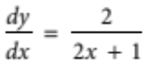 [2 marks]
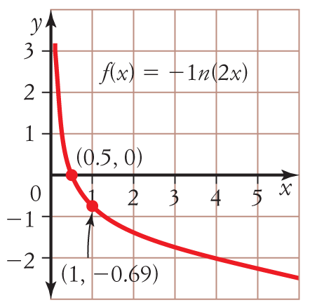
13?

[2]

[4 marks]
Domain (x : x > 0}, Range R [2]
14 Since 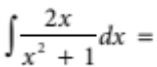 log_{e}(x²+1) + c
then 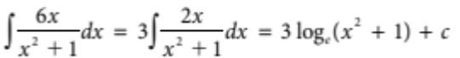 [2 marks]
15 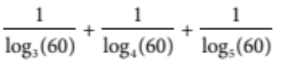
= 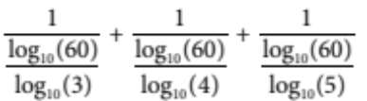 [1 mark]
= 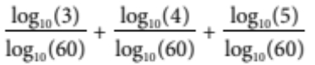 [1 mark]
= 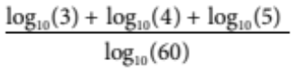
= 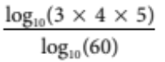
= 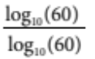 [1 mark]
= 1 [1 mark]

16 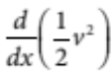= 6x2  4x  3
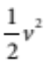= 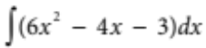 [1 mark]
= 2x3  2x2  3x  c
When x = 0, v = 3
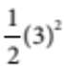 = 2(0)3  2(0)2  3(0)  c
c =
= 2x3  2x2  3x 
v2 = 4x3  4x2  6x + 9
v = 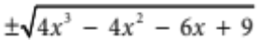 [1 mark]
The condition v = 3 when x = 0 is satisfied by:
v = 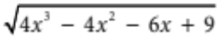 [1 mark]
When x = 2,
v = 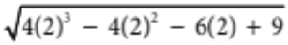
= 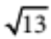
When x = 2, v = [1 mark]
17 a 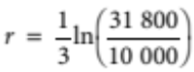
≈ 0.3856 [2 marks]
Therefore, the annual growth rate is 0.3856 or 38.56%.
b 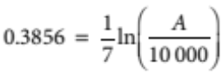
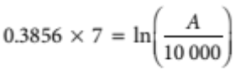
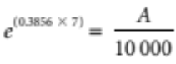
10 000e^{(0.3856 × 7)} = A
A = $148 678.33 [3 marks]
c 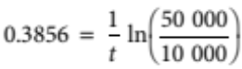
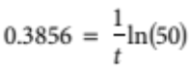
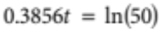
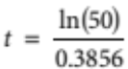
t = 10.1453 [3 marks]
Therefore, it will take 10.1453 years after the year 2009 for the $10 000 investment to grow to $500 000.
18
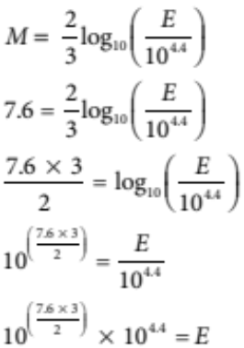

[1 mark]

E = 6.3 × 10¹⁵ joules [2 marks]

19 a i n = 100, t = 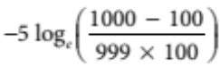
t = 23.5 days
ii n = 200, t = 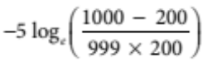
t = 27.6 days
iii n = 998, t = 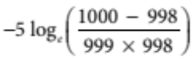
t = 65.6 days
iv n = 999, t = 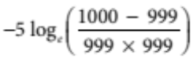
t = 69.1 days [4 marks]
b t = 35, 35 = 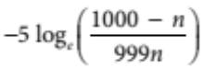 [1 mark]
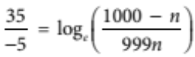
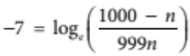
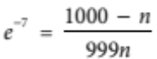
e^{–7} × 999n = 1000 – n
999e^{–7}n + n = 1000
n(999e^{–7} + 1) = 1000 [1 mark]
n = 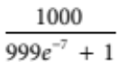
n = 523.3 [1 mark]
After 35 days there are 523 cows infected. The 0.3 means that cow number 524 has also contracted the disease partially. Therefore, there will be 524 cows infected after 35 days. [1 mark]

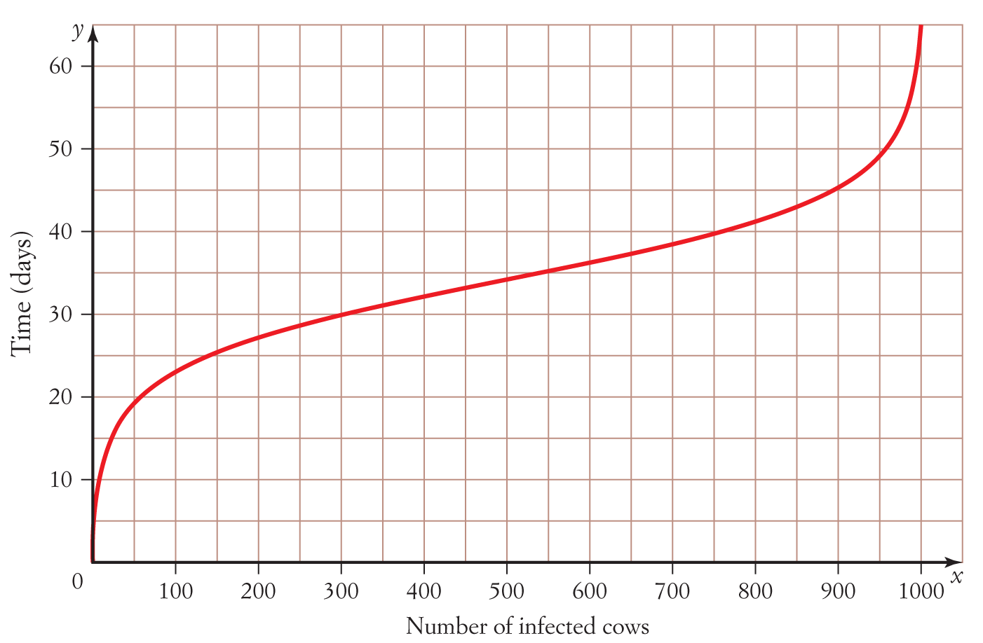
c

[2 marks]
d This contagious disease can spread very rapidly at first and then very slowly as nearly all of the population has become infected. It is called a logistic growth model.
[1 mark]

